**LAKSHITA RAWAT**

**BSC CS HONS (SEC-A)**

**16102**

**Q5.**

**CODE:-**

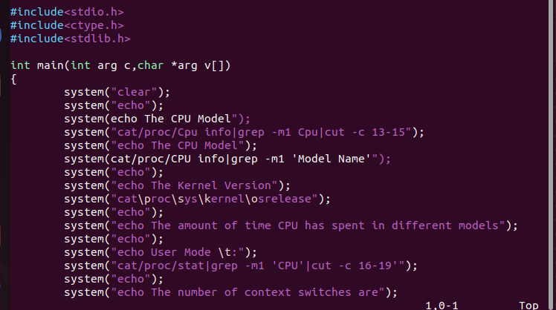

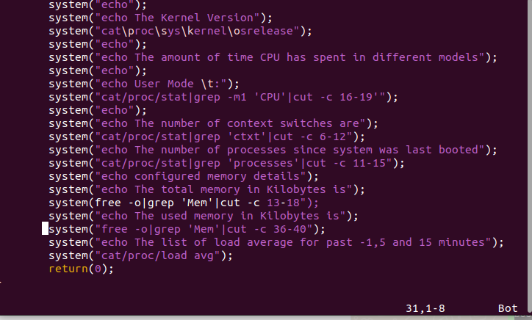

**OUTPUT:-**

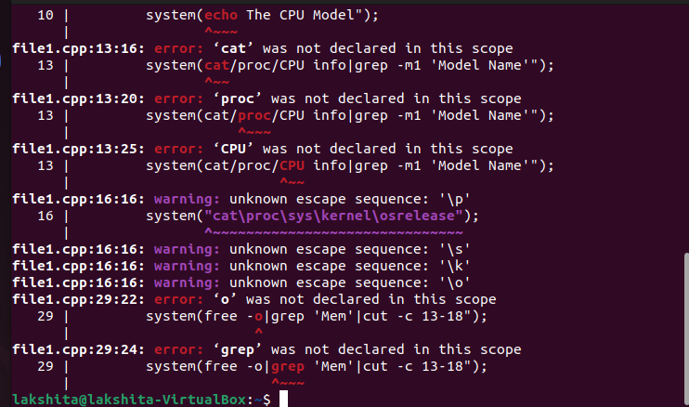

**Q6.**

**CODE:-**





**OUTPUT:-**



**Q7.**

**CODE:-**

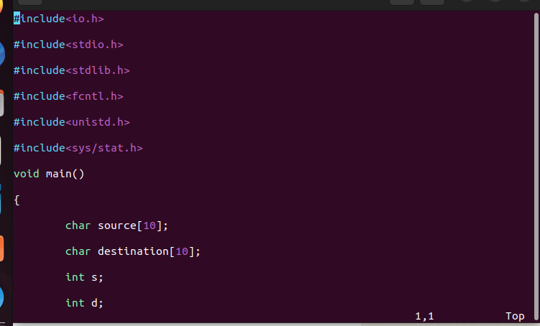

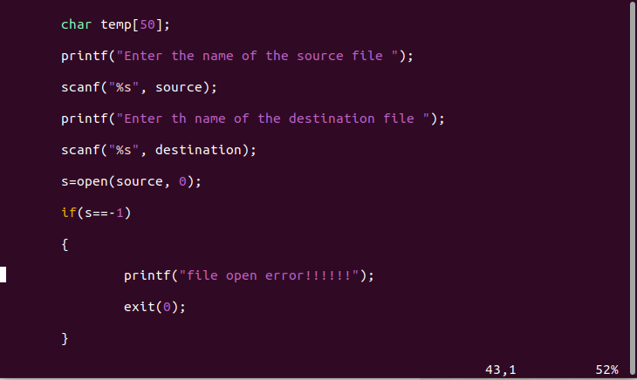

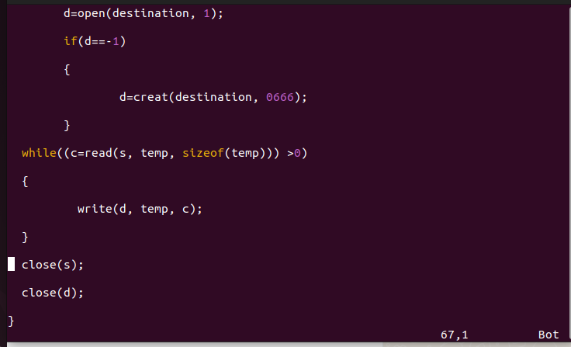

**OUTPUT:-**

